# SIAL: Spatio-Temporal Pattern Recognition in Spiking Neural Networks

## A delay learning approach to temporal pattern classification

Zaynab Nachabe

July 18, 2025

## Abstract

This research investigates the capacity of Spiking Neural Networks (SNNs) to learn and discriminate spatio-temporal patterns through Delay Learning alongside Spike-Timing-Dependent Plasticity (STDP). I implement a biologically plausible learning mechanism that enables neurons to autonomously specialize in recognizing specific temporal patterns between input spike trains. My approach demonstrates how temporal information can be encoded and processed in a manner inspired by the brain's neural dynamics, without requiring complex supervised learning algorithms. I evaluate the system using synthetic temporal patterns and analyze its performance in terms of accuracy, weight specialization, and robustness to noise. The results highlight the potential of delay learning as a foundation for neuromorphic computing systems capable of temporal pattern recognition.

## Table of Contents

1. Introduction
2. State of the art
3. Methodology
4. Results
5. Discussion
6. Conclusion
7. Appendix: Implementation Details
8. References

## Introduction

### Background and Motivation

Temporal pattern recognition represents a fundamental challenge in both biological and artificial intelligence systems. While conventional artificial neural networks excel at spatial pattern recognition, they often struggle with temporal dependencies and patterns that unfold over time. The brain, however, naturally processes temporal information through precise spike timing relationships between neurons [1].

### Research Objectives

This research aims to:

* Develop a biologically plausible SNN capable of learning to discriminate between different spatio-temporal patterns
* Implement a delay learning rule that allows autonomous specialization of output neurons
* Analyze the effectiveness of lateral inhibition and competitive learning in enhancing pattern discrimination
* Investigate the role of homeostatic mechanisms in maintaining stable learning
* Evaluate the model's performance in terms of classification accuracy and other metrics.

## State of the Art

### Spiking Neural Networks

SNNs represent the third generation of neural network models, incorporating temporal dynamics and event-based processing [3]. Unlike traditional artificial neural networks, SNNs communicate through discrete events (spikes) that occur at specific points in time, thus naturally encoding temporal information.

### Spike-Timing-Dependent Plasticity

STDP is a biological learning mechanism observed in various brain regions, where the strength of synaptic connections is modified based on the relative timing of pre- and post-synaptic spikes [2]. When a presynaptic neuron fires shortly before a postsynaptic neuron, the connection is strengthened (potentiation); conversely, when the order is reversed, the connection is weakened (depression).

### Temporal Pattern Recognition in SNNs

Prior work on temporal pattern recognition using SNNs has explored various approaches:

* Delay learning mechanisms [4]
* Reservoir computing with SNNs [5]
* Temporal coding schemes [6]
* Unsupervised STDP-based learning [7]

### Lateral Inhibition and Competition in Neural Networks

Lateral inhibition, where active neurons suppress the activity of neighboring neurons, plays a crucial role in creating competition and enabling specialization in neural networks [8]. This mechanism is particularly important for unsupervised learning scenarios where neurons need to self-organize.

## Methodology

### Dataset generation

My dataset is constructed with spatio-temporal patterns with specific spike timing relationships between two input neurons.

Pattern 1: input 1 fires then input 2 fires 8 ms after

Pattern 2: Input 2 fires, then Input 1 fires 8 ms

Pattern 3: Both inputs fire simultaneously*

30 ms between pattern representations

5 patterns in each chunk of simulation

*for simplification this pattern was removed in just_delay.py and stdp_delay.py to observe results more clearly.

Additional pattern testing should be done for those two cases.

### Network Topology 1

* Input layer: neurons that receive timed input patterns
* Output layer: neurons that learn to respond to specific patterns
* Lateral inhibitory connections: creating competition between output neurons

|  |
| --- |

### 

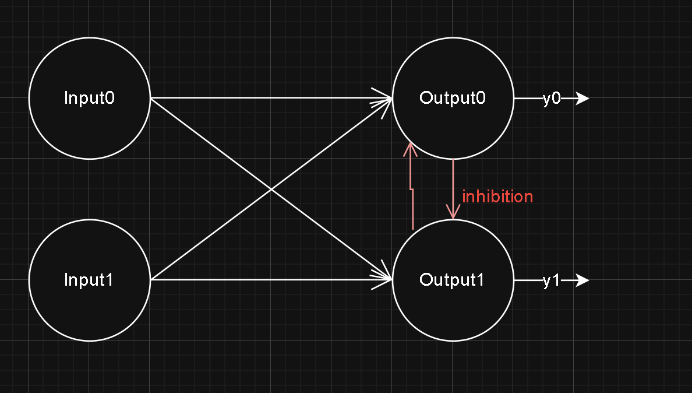

Network Topology 2

This second network topology is used for the just_delay and stpd_and_delay networks, it's a simpler version of the original one, meant to detect only 2 spatio-temporal patterns.

Convolutional Approach

Inspired by the work of Hugo Bulzomi and Ameli Gruel in their respective repositories :

[HugoBulzomi/SNN_Delay_Learning](https://github.com/HugoBulzomi/SNN_Delay_Learning)

This approach implements a neuromorphic convolutional neural network to learn and recognize spatio-temporal patterns from audio signals, specifically orca whale sounds

* It creates multiple convolution layers (2-8 layers) with 5x5 filters.
* Each layer specializes in detecting a specific pattern through learning.

### The delay learning Rule [16]

This rule focuses on adjusting synaptic delays to promote learning temporal patterns. Specifically, the change in synaptic delay (Δdi,j) is governed by a function G that depends on the time difference (Δti,j) between the firing of the pre-synaptic and post-synaptic neurons, adjusted by the current delay di,j. The proposed rule is as follows:

Δdi,j=G(Δti,j)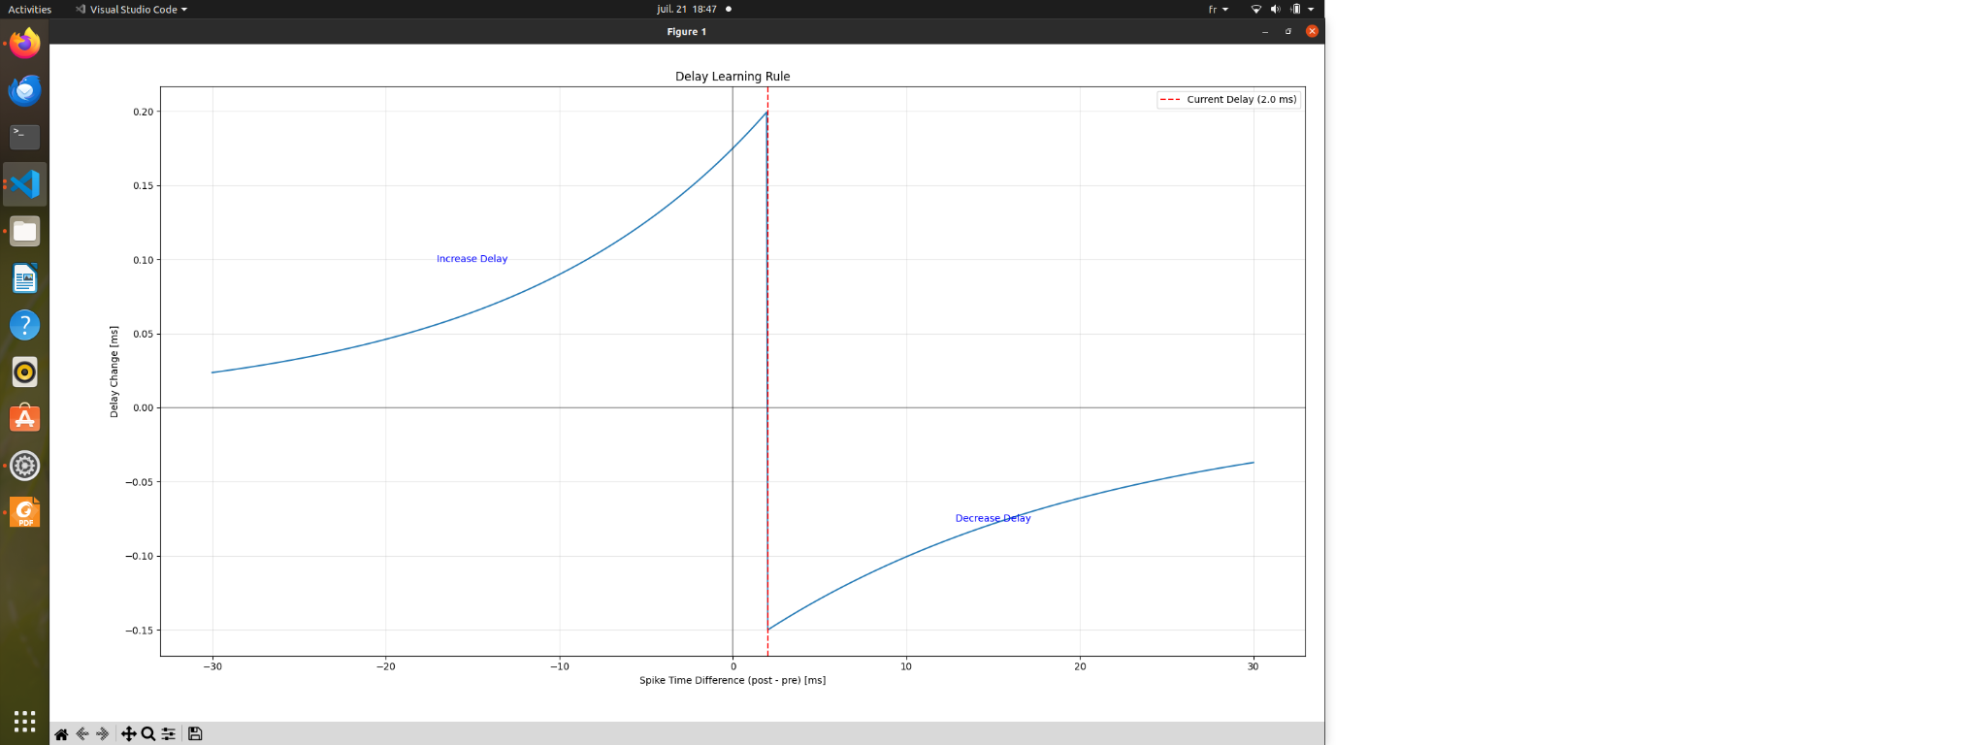

Where: Δti,j=tj−ti−di,j

The function G is defined piecewise:

* If Δti,j≥0, then Δdi,j=−B−exp⁡(−Δti,jσ−)
* If Δti,j<0, then Δdi,j=B+exp⁡(Δti,jσ+)

Here, B+ and B− are parameters controlling the magnitude of synaptic delay reduction and increment, respectively. σ+ and σ− are time constants related to the causal effect of the pre-synaptic neuron on the post-synaptic neuron's firing. This mechanism allows the network to adjust delays to improve the timing of spike arrivals, thereby enhancing the learning of temporal features within the SNN.

This approach is biologically plausible and has been demonstrated in the paper to be effective in extracting temporal patterns.

### Experimental Setup

#### Spatio-Temporal Patterns

We define three distinct patterns:

1. Pattern 1: sequential activation
2. Pattern 2: sequential activation with reversed order
3. Pattern 3: simultaneous activation of inputs*

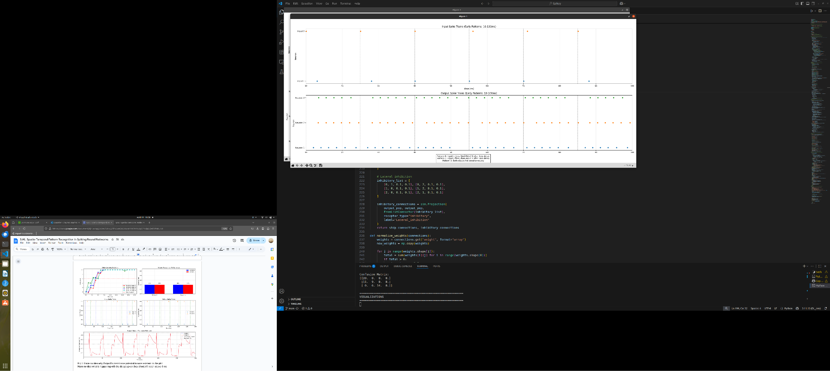

#### Simulation Parameters

| Parameter | Value |
| --- | --- |
| Neuron model | Leaky integrate-and-fire |
| Membrane time constant | 10 ms (reduced) |
| Resting potential | -65 mV |
| Threshold potential | -55 mV |
| Reset potential | -70 mV |
| STDP A+ | 0.2 |
| STDP A- | 0.1 |
| STDP τ+ | 15 ms |
| STDP τ- | 30 ms |
| Inhibitory weight | 0.3 |

### Evaluation Metrics

I assess the models using:

* Membrane potential dynamics
* Classification accuracy
* Weight specialization (measured by the standard deviation of weights)
* Response specificity of output neurons
* Robustness to noise (not tested with all networks)

And for the convolutional approach, I keep the metrics used before:

* Precision
* Recall
* GINI score
* F1 score
* Learning convergence and filter evolution over time

## Results

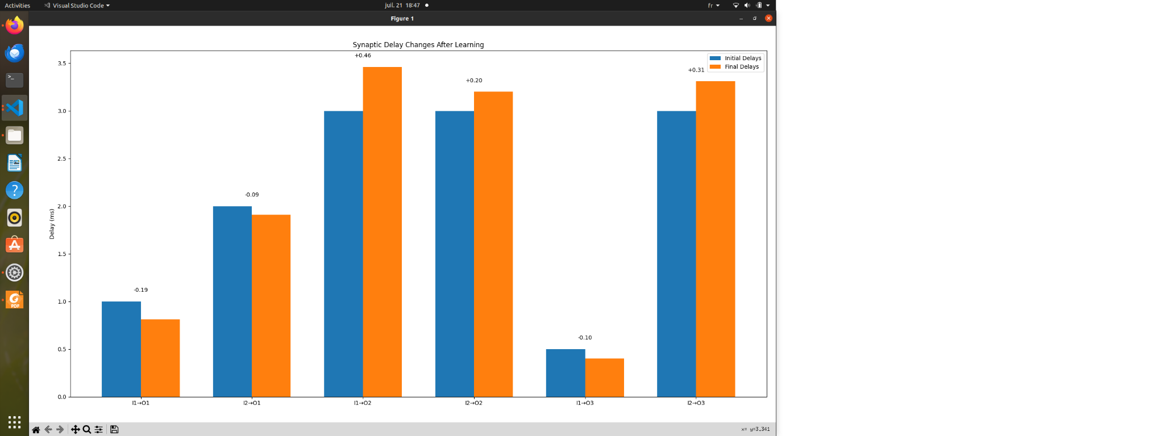

Fig2: Difference of delays between the beginning of the simulation and the end of the simulation in the case of delay learning

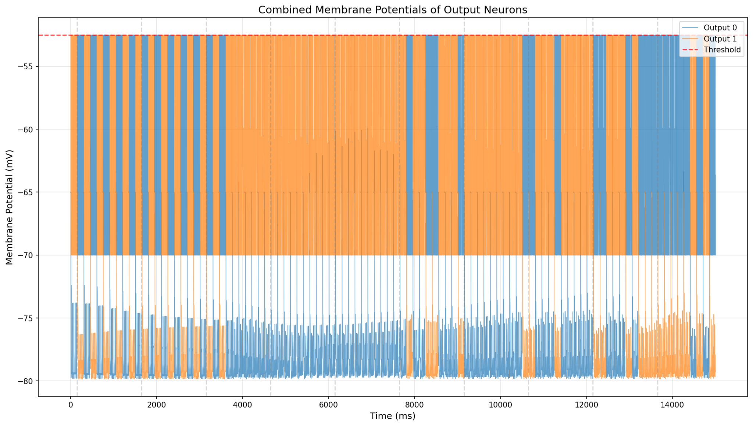

Fig: Membrane potential of Output0 and Output1 in just_delay during the entire simulation.

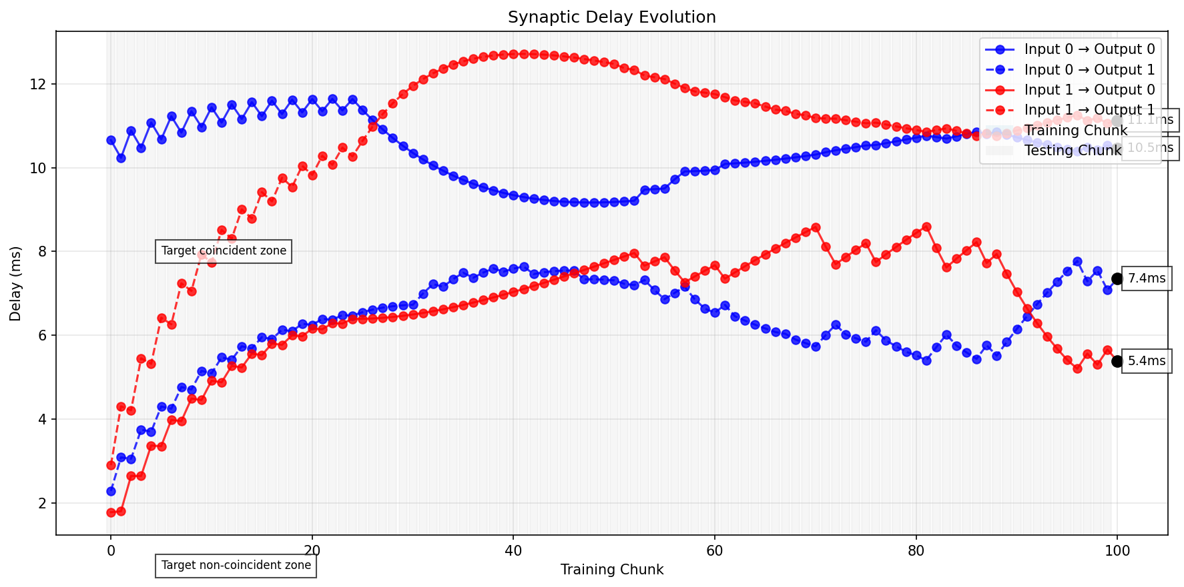

Fig: Evolution of the connection’s delays in just_delay.py

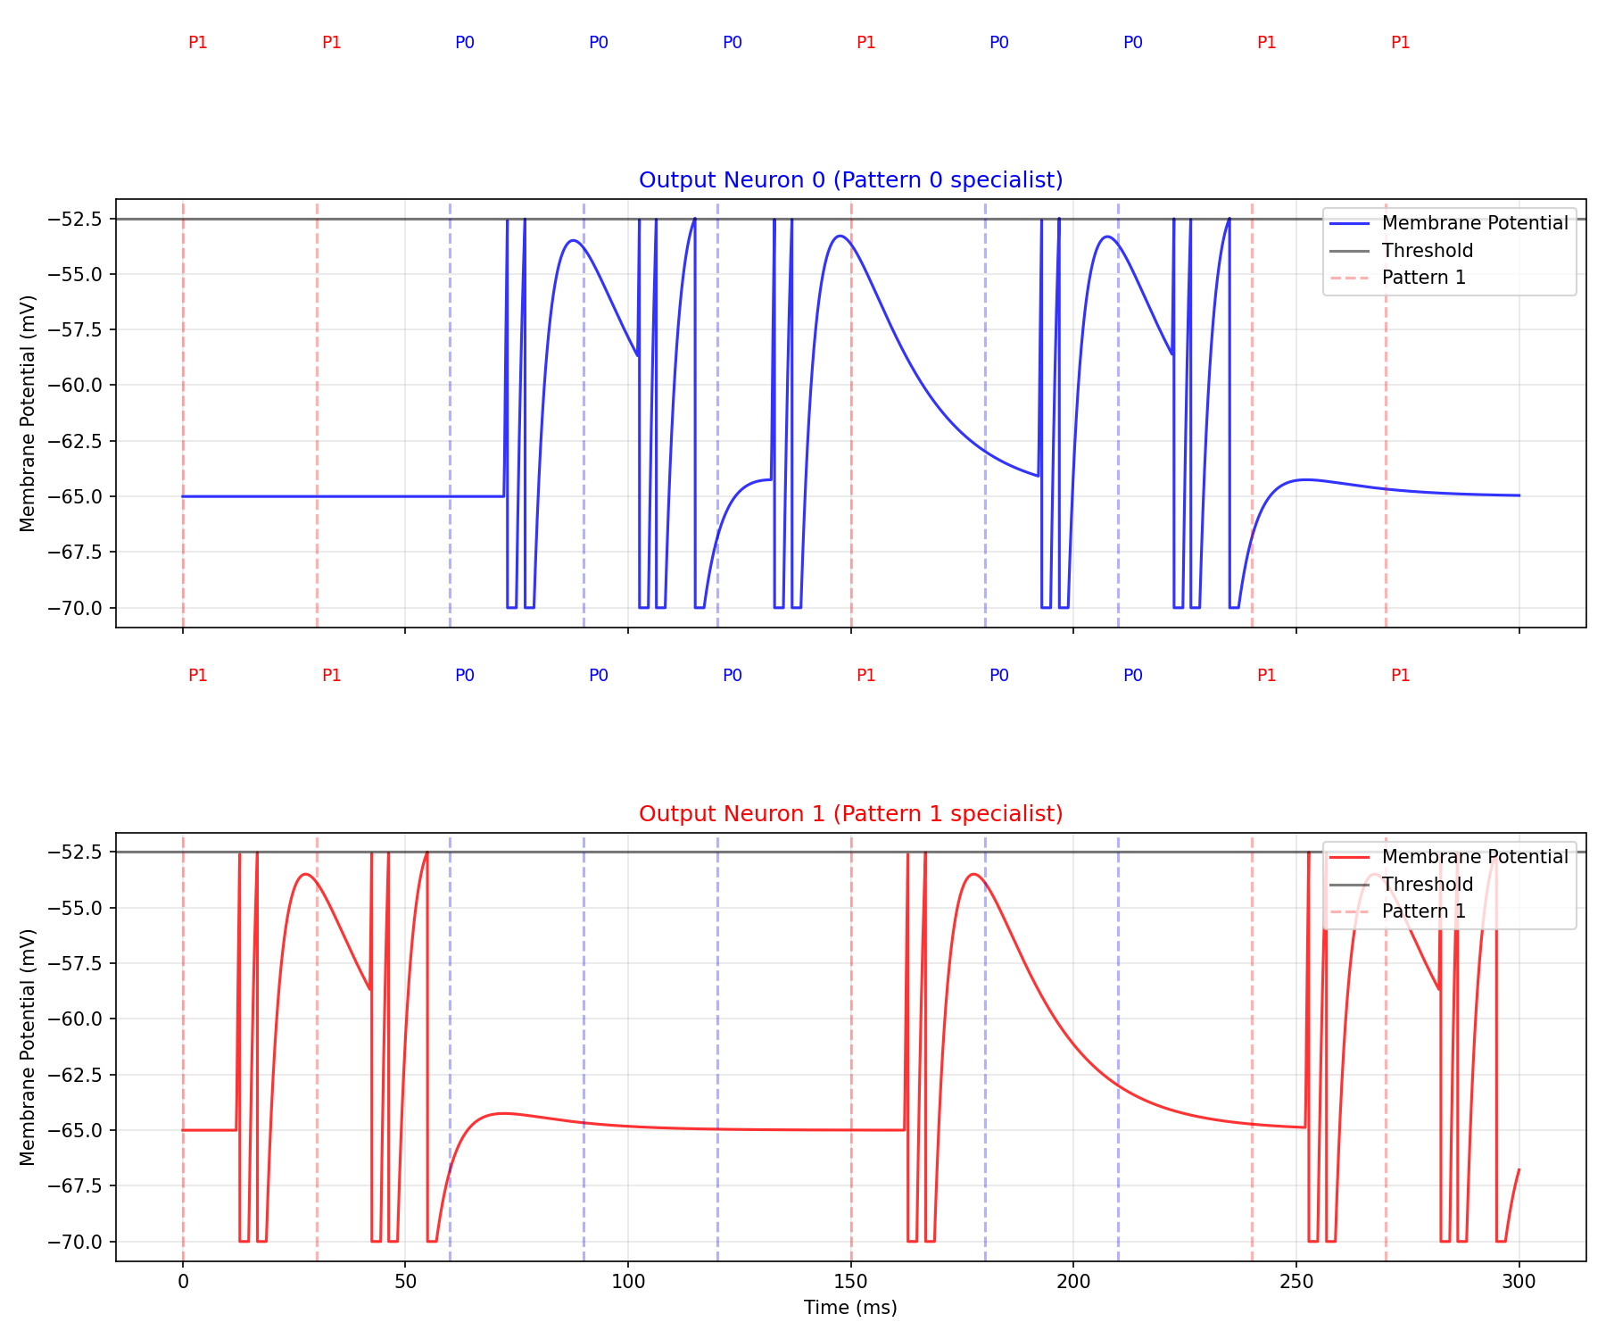

Fig3:

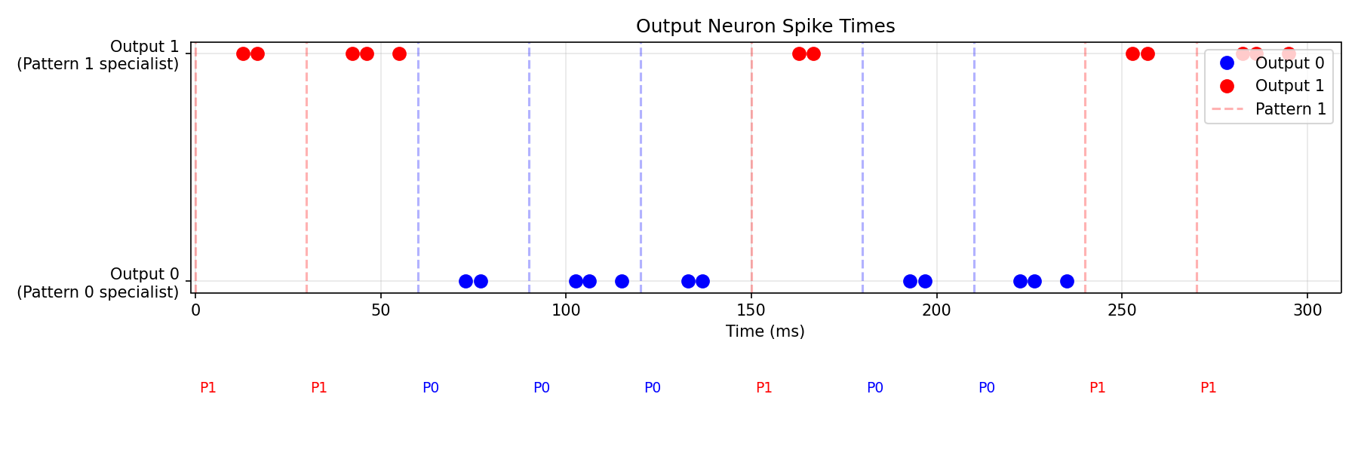

Fig4:

### Pattern Classification Performance

Since pattern 3 is proving difficult to detect, I decided to omit it from more complicated approaches, but for fair comparison it should be added later.

### Delay Specialization Analysis

The synaptic delays should evolve to enable each output neuron to specialize in detecting specific patterns.

So in ideal conditions, some delays would go down to 1 ms depending on what neuron in specializing in what pattern.

And some other delays should go up to 8 ms. In a more complex state the delays should go down to zero with patterns that are already coincident.

## Discussion

### Interpretation of Results

According to my findings and looking at research papers from other labs and people who have worked on the same problem. It seems like delay learning is not sufficient by itself just yet. It performs much better when applied with STDP on weights, and adds an advantage in noise robustness.

When it comes to edge devices, if the task is simple enough the network could be made very simple which makes it much more cost effective.

### Comparison

3 comparisons :

Dumbo network : fixed weights, and strategically random delays

STDP network: learnable weights, purely random delays

Delay Learning network: learnable weights and delays.

Note: a comparison with a network that uses both delay learning and weight learning would be very interesting in this context, however the results from this experiment weren’t satisfactory yet.

|  | Accuracy without noise | Accuracy with noise |
| --- | --- | --- |
| Fixed weights and delays | 58.33% | ~20% |
| STDP (learned weights) | ~70% | 31.67% |
| Delay learning (fixed weights) | 90% | 66% |
| Learn both delays and weights | – | – |

### Limitations

* Limited pattern complexity
* Sensitivity to parameter tuning
* Scalability challenges
* Need for careful delay/weight initialization to break symmetry.

### Future Work

* Extension to more complex and real-world temporal patterns
* Integration of additional biologically inspired mechanisms

## Conclusion

This research demonstrates that a simple network of spiking neurons applying the delay learning rule in [16] equipped with STDP and lateral inhibition can effectively learn to discriminate between different spatio-temporal patterns. The results could highlight the potential of biologically inspired approaches for temporal pattern recognition tasks and point to promising directions for further research in neuromorphic computing.

### References

[1] Markram, H., Gerstner, W., & Sjöström, P. J. (2012). Spike-timing-dependent plasticity: a comprehensive overview. Frontiers in synaptic neuroscience, 4, 2.

[2] Bi, G. Q., & Poo, M. M. (1998). Synaptic modifications in cultured hippocampal neurons: dependence on spike timing, synaptic strength, and postsynaptic cell type. Journal of neuroscience, 18(24), 10464-10472.

[3] Maass, W. (1997). Networks of spiking neurons: the third generation of neural network models. Neural networks, 10(9), 1659-1671.

[4] Ponulak, F., & Kasinski, A. (2010). Supervised learning in spiking neural networks with ReSuMe: sequence learning, classification, and spike shifting. Neural computation, 22(2), 467-510.

[5] Maass, W., Natschläger, T., & Markram, H. (2002). Real-time computing without stable states: A new framework for neural computation based on perturbations. Neural computation, 14(11), 2531-2560.

[6] Gerstner, W., & Kistler, W. M. (2002). Spiking neuron models: Single neurons, populations, plasticity. Cambridge university press.

[7] Masquelier, T., & Thorpe, S. J. (2007). Unsupervised learning of visual features through spike timing dependent plasticity. PLoS computational biology, 3(2), e31.

[8] McCormick, D. A., McGinley, M. J., & Salkoff, D. B. (2006). Inhibitory control of cortical activation in humans. Current opinion in neurobiology, 16(5), 578-584.

[9] Diehl, P. U., & Cook, M. (2015). Unsupervised learning of digit recognition using spike-timing-dependent plasticity. Frontiers in computational neuroscience, 9, 99.

[10] Tavanaei, A., Ghodrati, M., Kheradpisheh, S. R., Masquelier, T., & Maida, A. (2019). Deep learning in spiking neural networks. Neural Networks, 111, 47-63.

[11] Kasabov, N. K. (2019). Time-space, spiking neural networks and brain-inspired artificial intelligence. Springer.

[12] Pfeiffer, M., & Pfeil, T. (2018). Deep learning with spiking neurons: opportunities and challenges. Frontiers in neuroscience, 12, 774.

[13] Paugam-Moisy, H., Martinez, R., & Bengio, S. (2012). Delay learning and polychronization for reservoir computing. Neurocomputing, 71(7-9), 1143-1158.

[14] Izhikevich, E. M. (2006). Polychronization: computation with spikes. Neural computation, 18(2), 245-282.

[15] Panzeri, S., Macke, J. H., Gross, J., & Kayser, C. (2015). Neural population coding: combining insights from microscopic and mass signals. Trends in cognitive sciences, 19(3), 162-172.

[16] Nadafian, A., & Ganjtabesh, M. (2020). Bio-plausible Unsupervised Delay Learning for Extracting Temporal Features in Spiking Neural Networks